Que(i) Select unique job from EMP table.

**Ans**(i): select DISTINCT Job from emp;

Output:

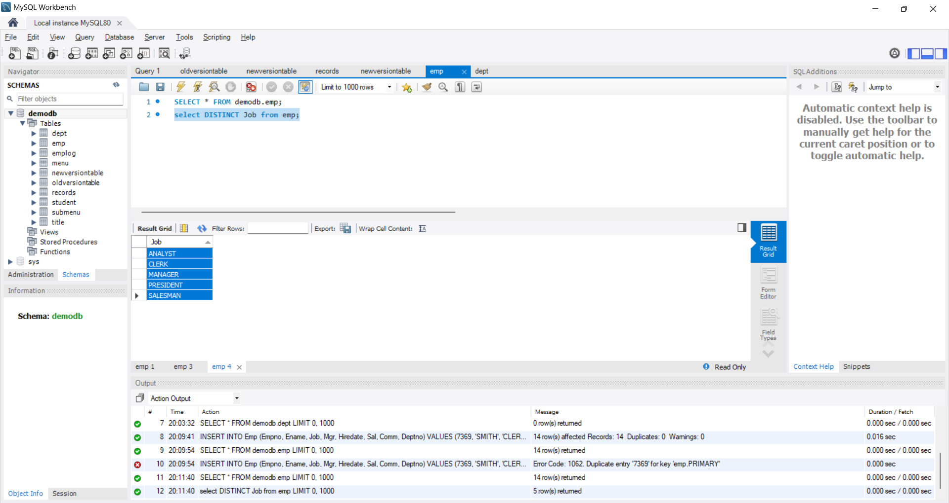

**Ans**(ii): select *from emp order by Deptno ASC , Job DESC ;

Output:

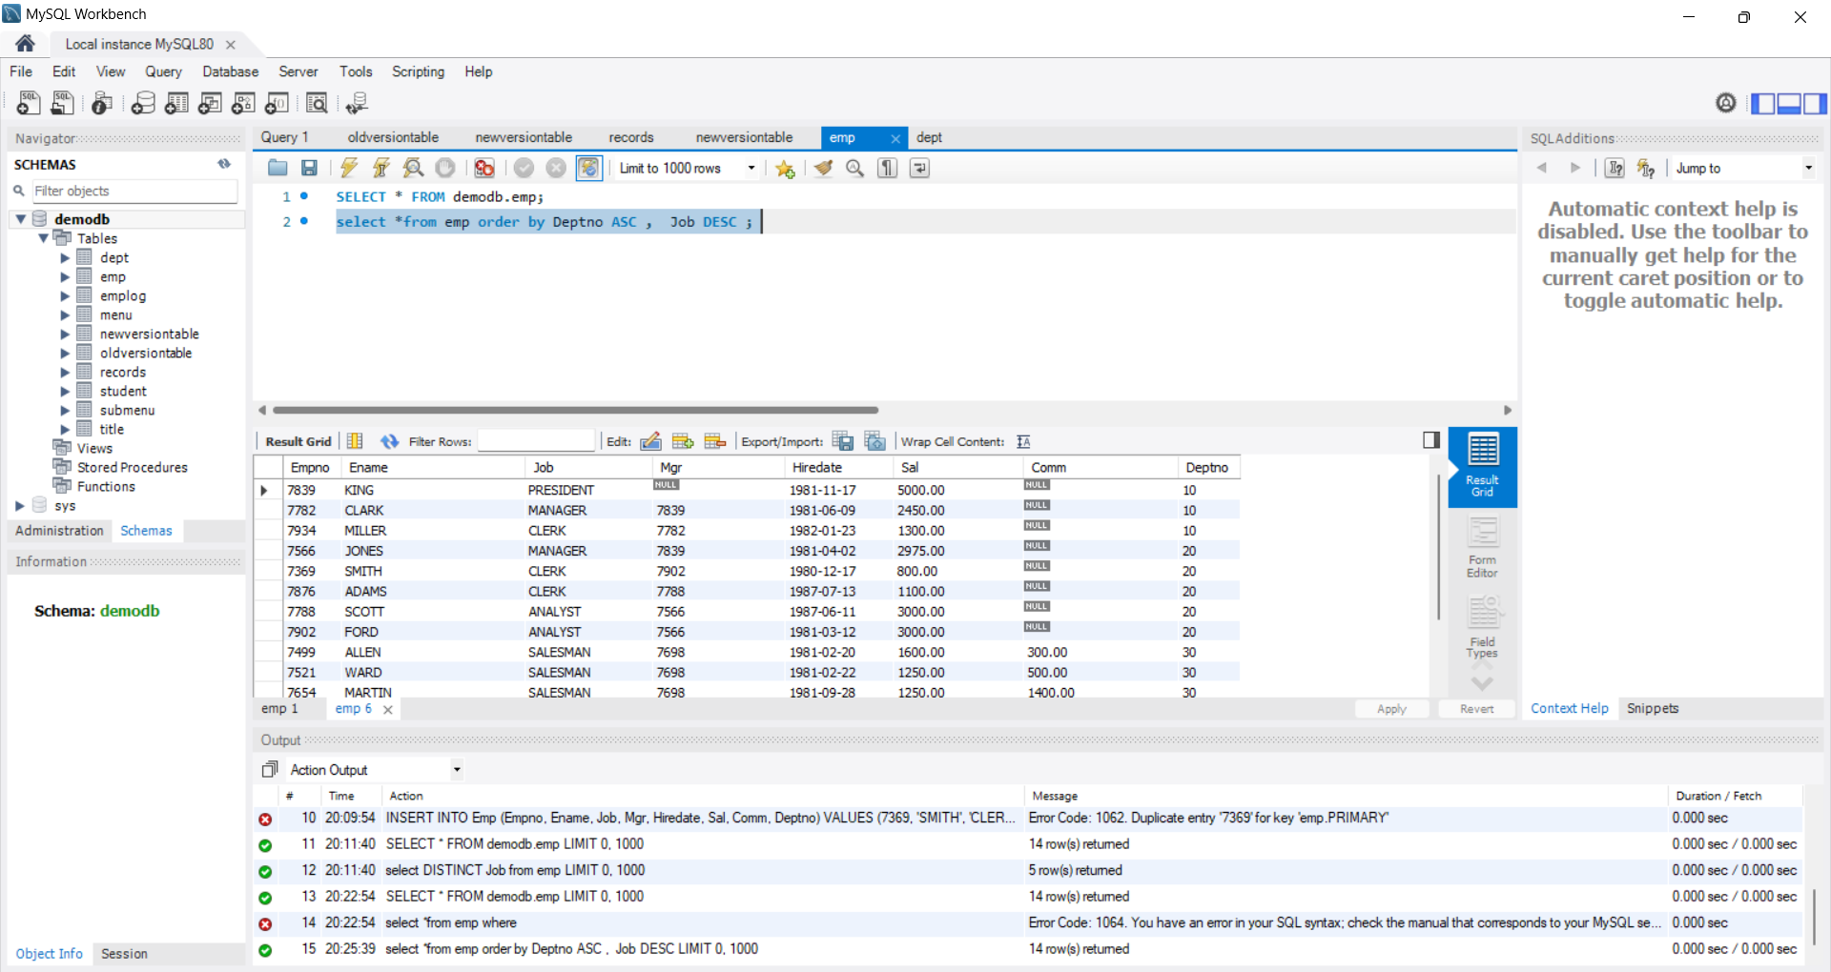

**Ans**(iii) select DISTINCT Job from emp order by Job DESC;

Output:

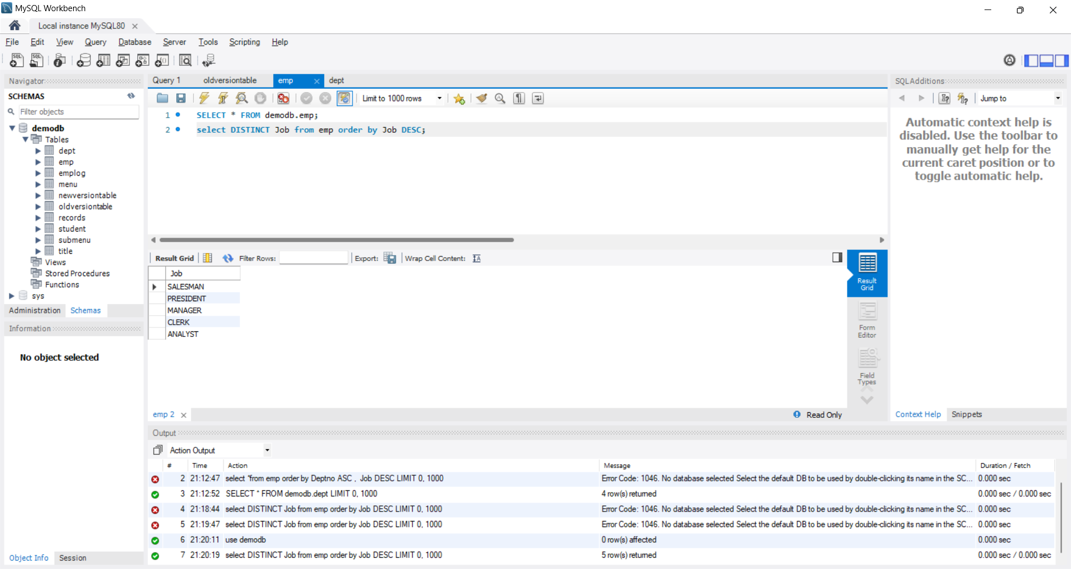

**Ans**(iv}: select Ename, Hiredate from emp where Hiredate <'1981-01-01';

Output:

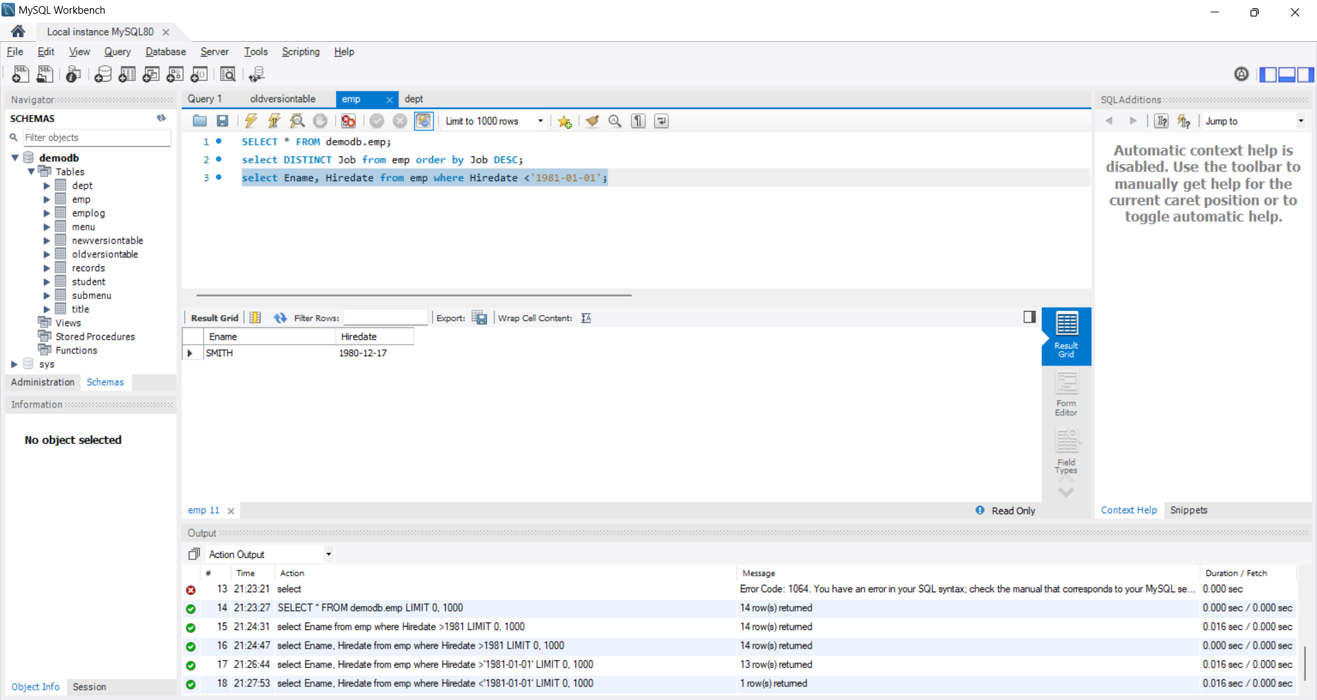

**Ans**(v) : SELECT Empno, Ename, Sal, Sal / 30 AS Daily_Sal FROM emp ORDER BY Sal * 12 ASC;

Output:

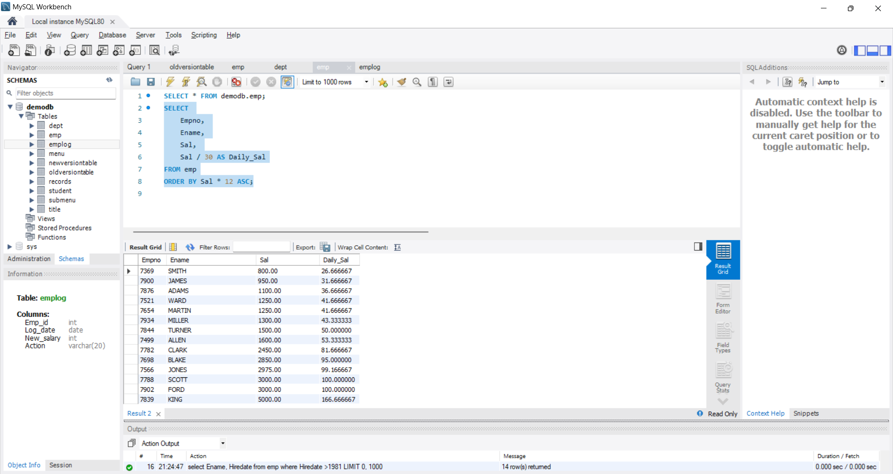

**Ans**(vi): select Empno,Ename,Sal,Mgr from emp where Mgr =7566;

Output:

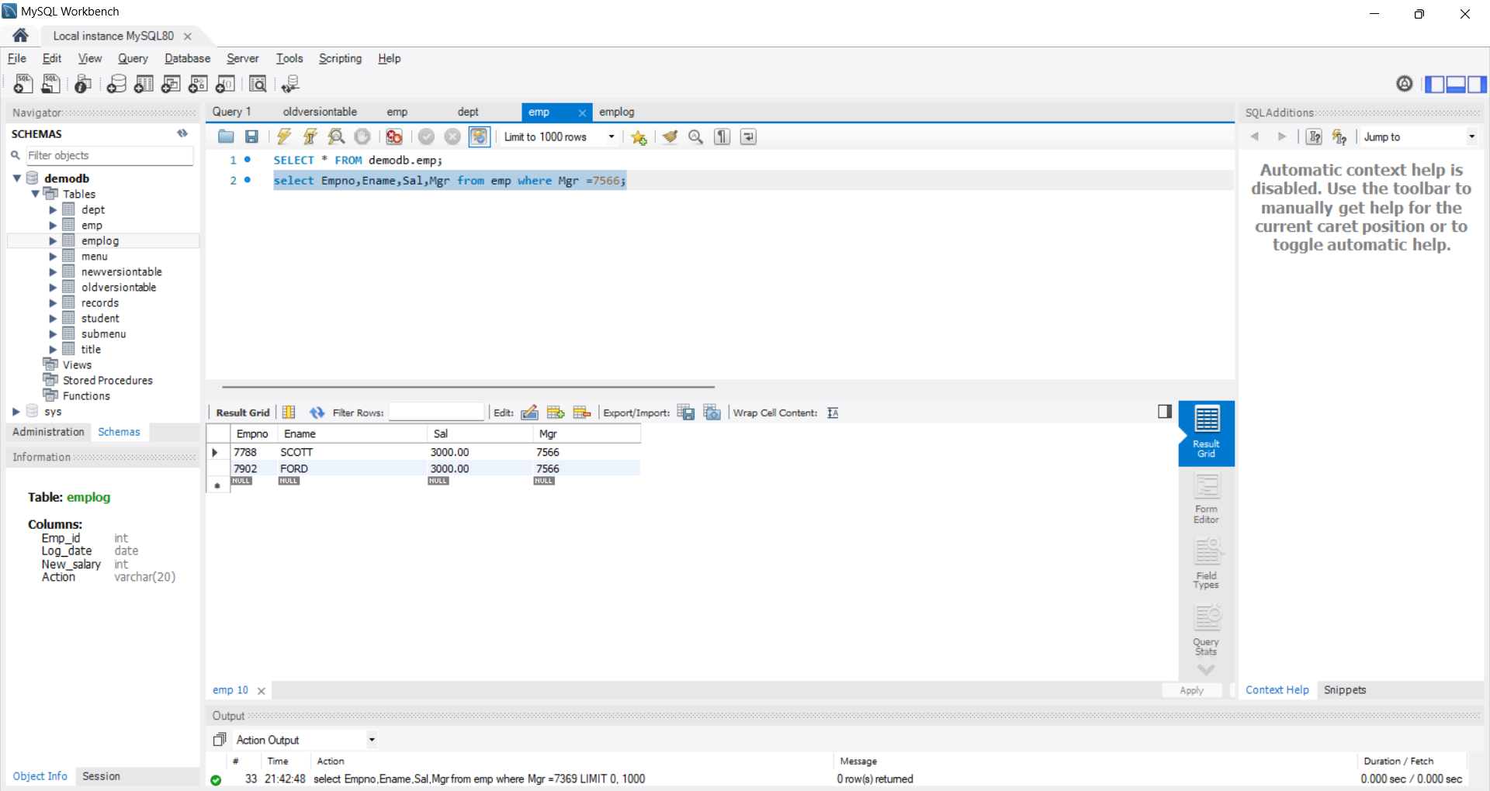

**Ans**(vii): select * from emp where Comm>Sal;

Output:

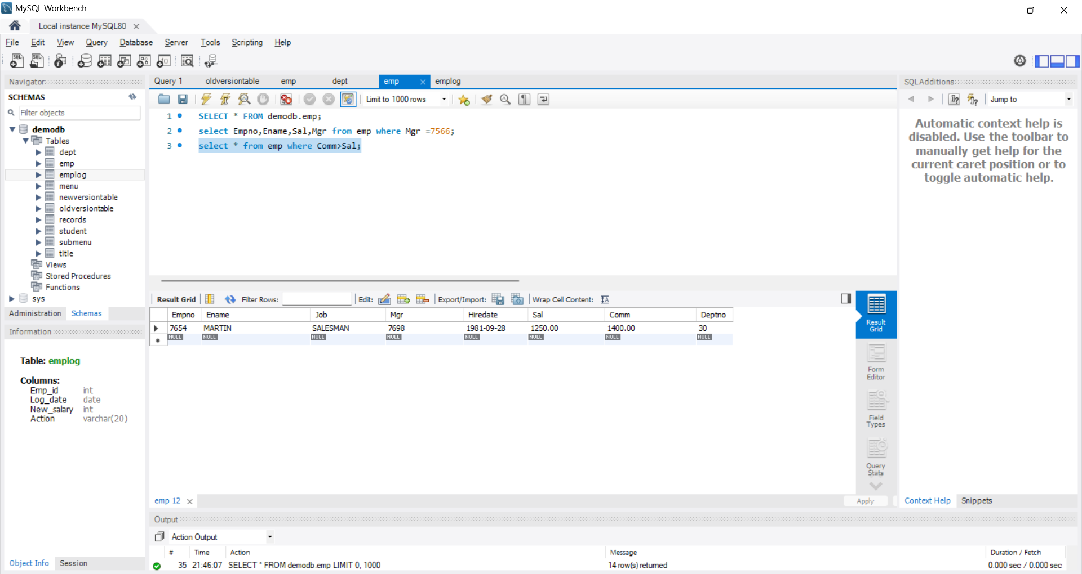

**Ans**(viii}: select Ename,Job from emp where Job='CLERK' OR Job='ANALYST' order by Job DESC;

Output:

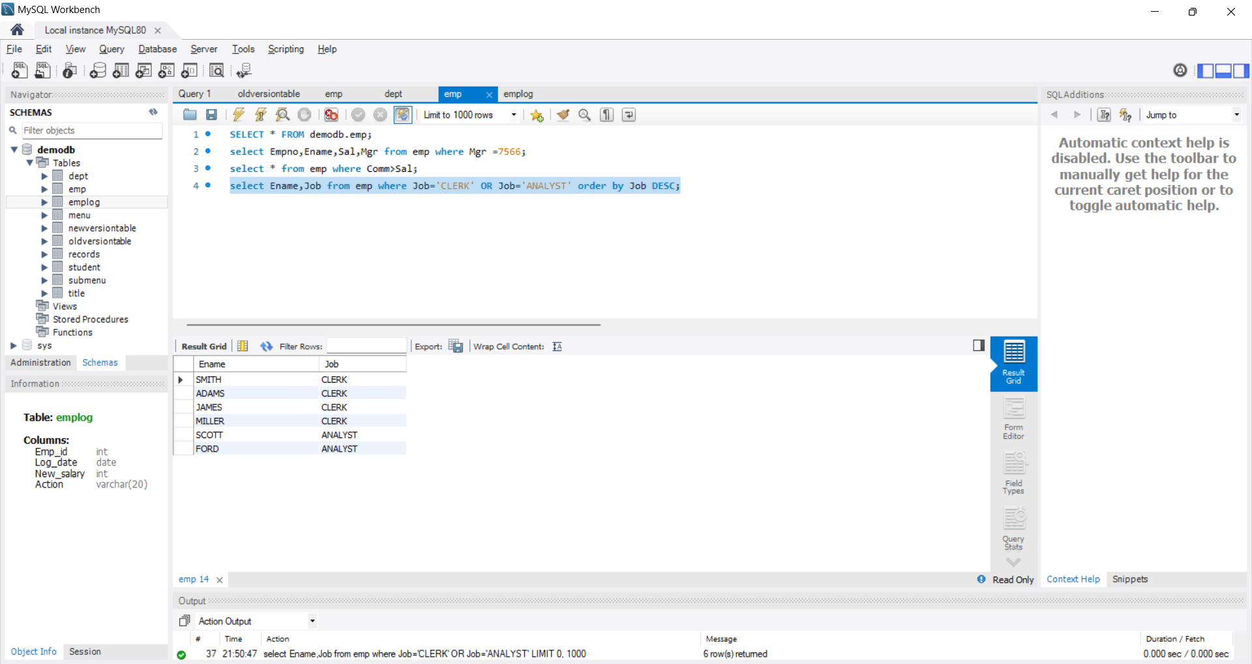

**Ans**(ix): select * from emp where (Sal*12) between 22000 AND 45000;

Output:

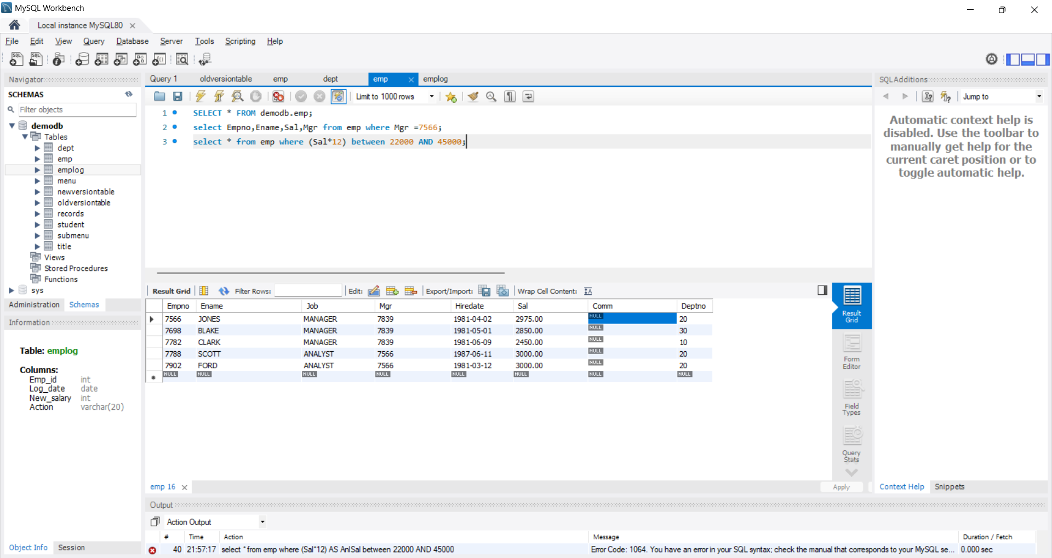

**Ans**(x): select Ename from emp where Ename LIKE 'S____%';

Output:

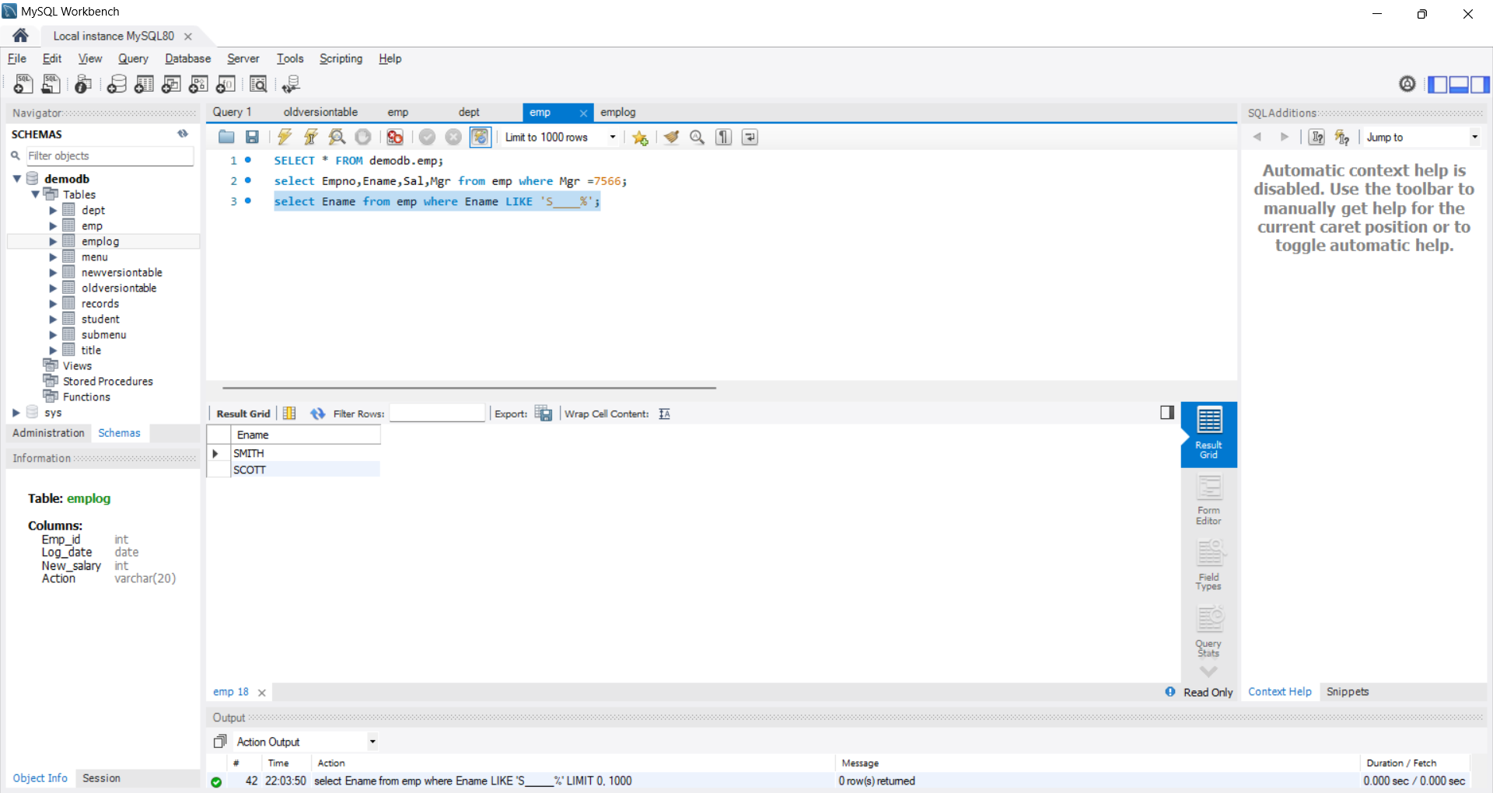

**Ans**(xi): select Ename,Empno from emp where Empno NOT LIKE '78%';

Output:

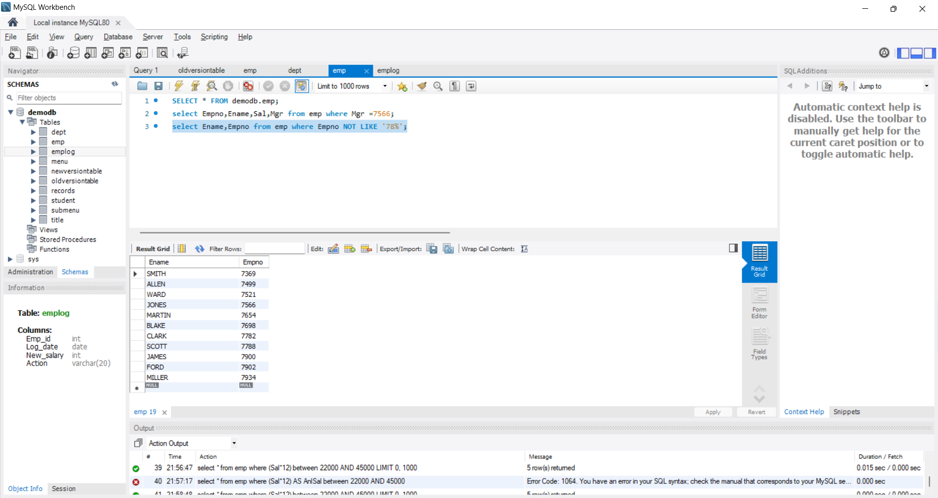

**Ans**(xii): select *from emp where Job='CLERK' AND Deptno=20;

Output:

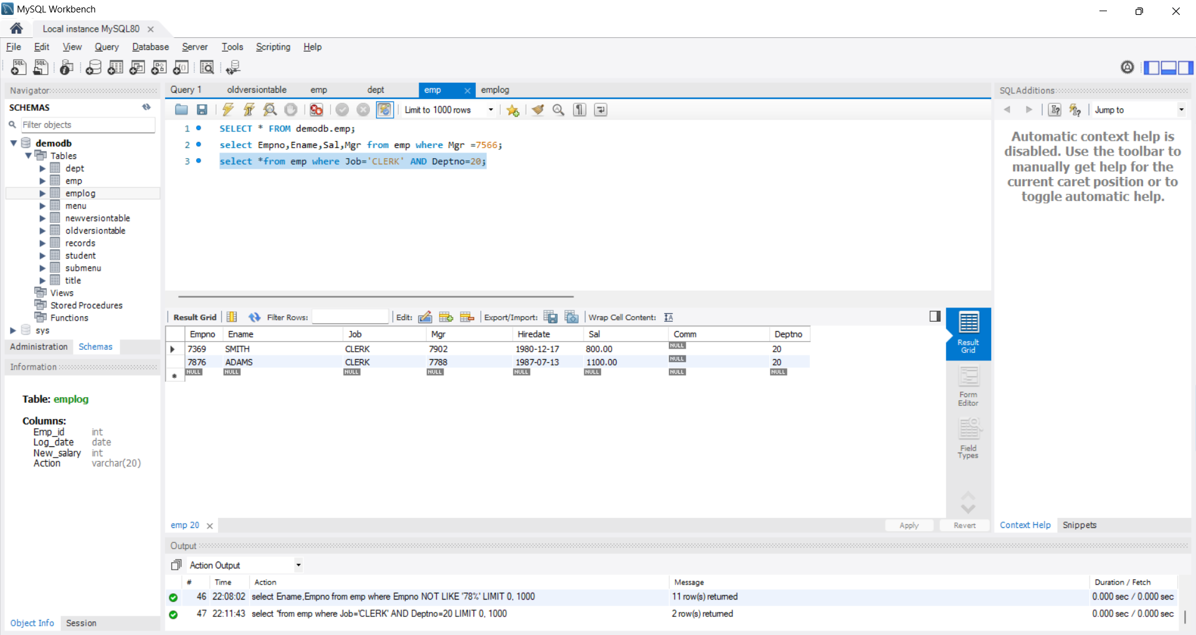

**Ans**(xiii): select e.Empno,e.Ename , e.Hiredate AS empHiredate, h.Hiredate AS MgrHiredate

from emp e

JOIN emp h ON e.mgr=h.Empno

where e.Hiredate<h.Hiredate;

Output:

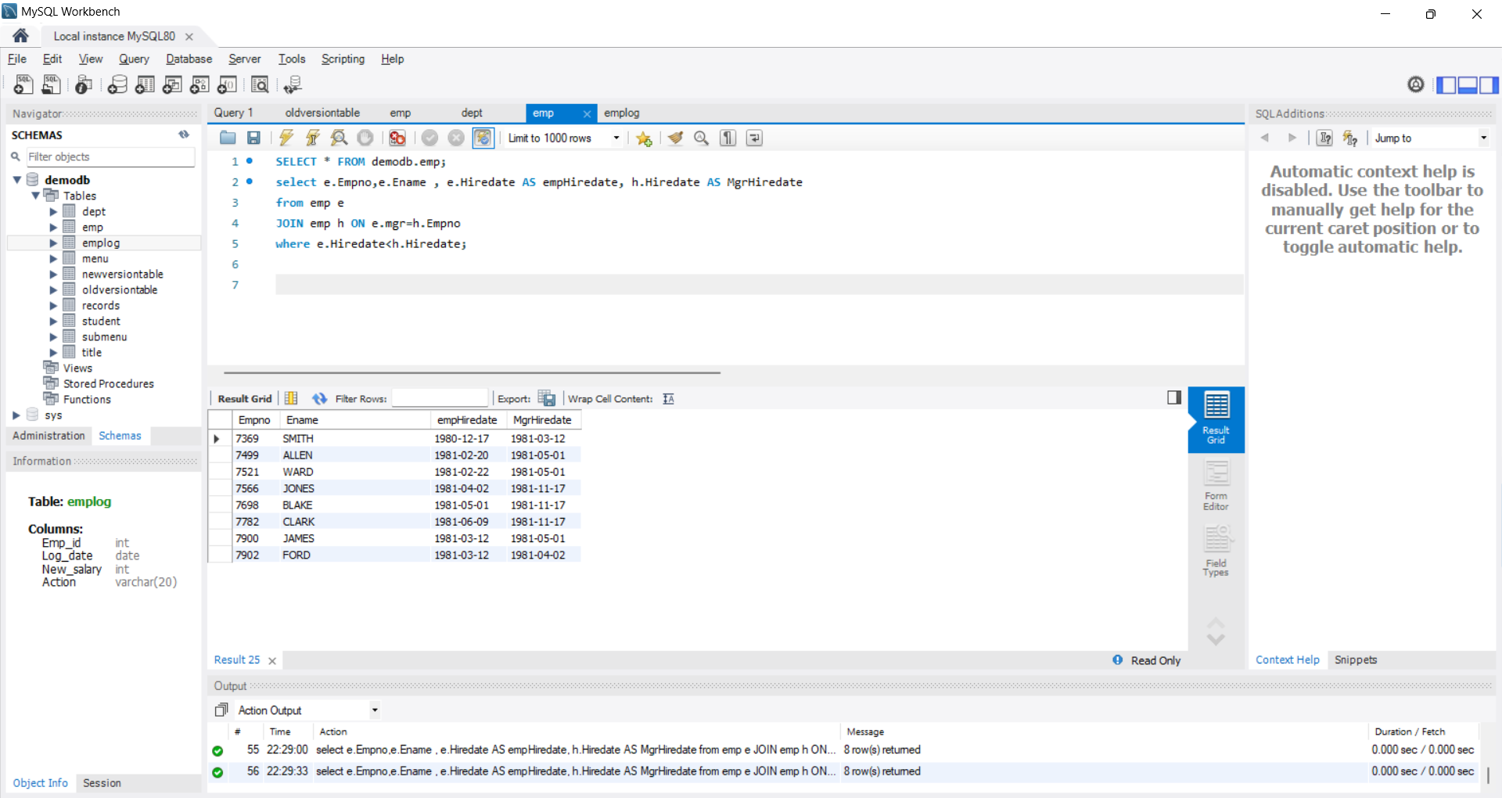

**Ans**(xiv) select e.Empno,e.Ename,e.Job,e.Mgr,e.Hiredate,e.Sal,e.Deptno,s.Deptno As Dp10 from emp e JOIN emp s ON e.Job=s.Job where e.Deptno=20 AND s.Deptno=10;

Output:

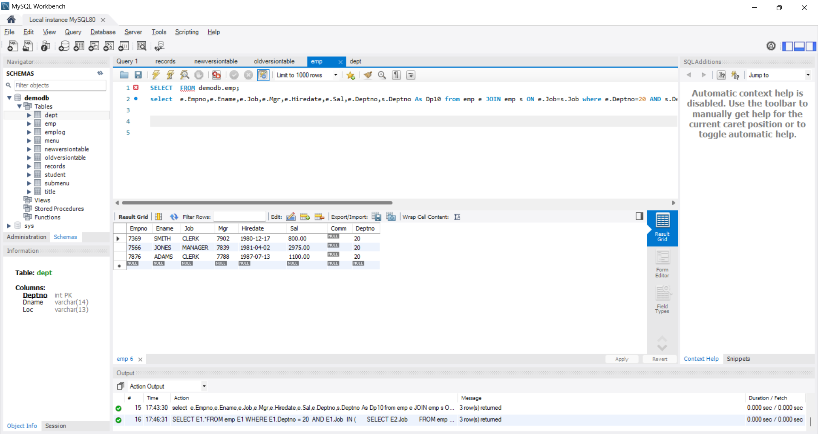

**Ans**(xv) SELECT e.Empno, e.Ename, e.Sal FROM emp e WHERE e.Sal IN

( SELECT s.Sal FROM emp s WHERE s.Ename IN ('FORD', 'SMITH')

) ORDER BY e.Sal DESC;

Output:

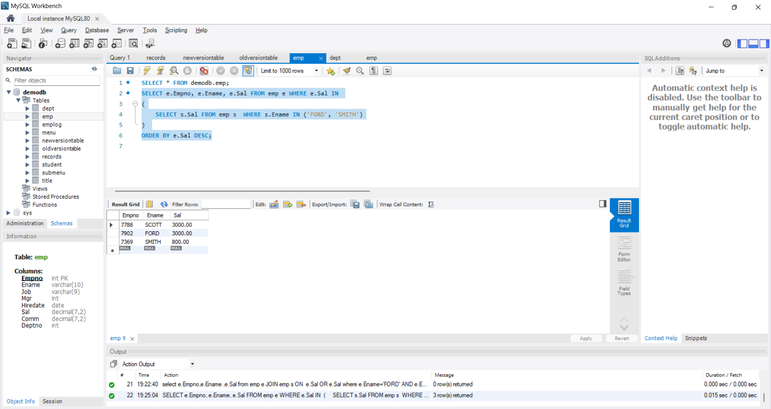

**Ans**(xvi) SELECT e.Empno, e.Ename, e.Sal FROM emp e WHERE e.Job IN

( SELECT s.Job FROM emp s WHERE s.Ename IN ('FORD', 'SMITH') ) ;

Output:

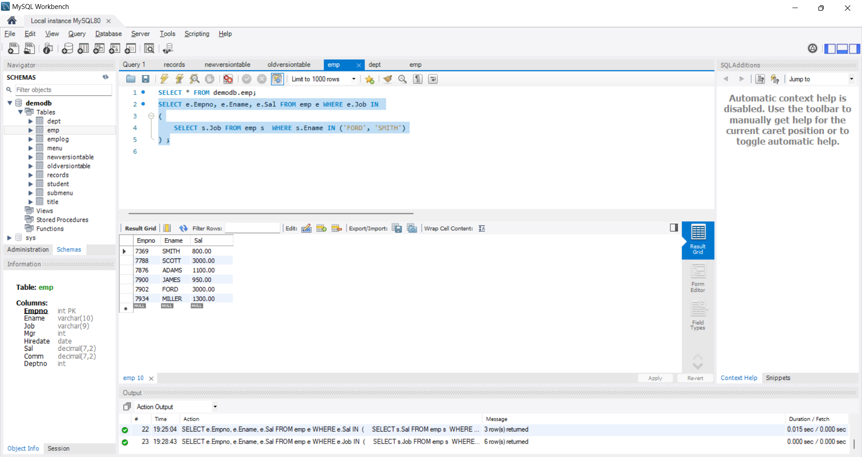

**Ans**(xvii) SELECT DISTINCT Job FROM emp WHERE Deptno = 10 AND Job NOT IN

( SELECT Job FROM emp WHERE Deptno = 20 );

Output:

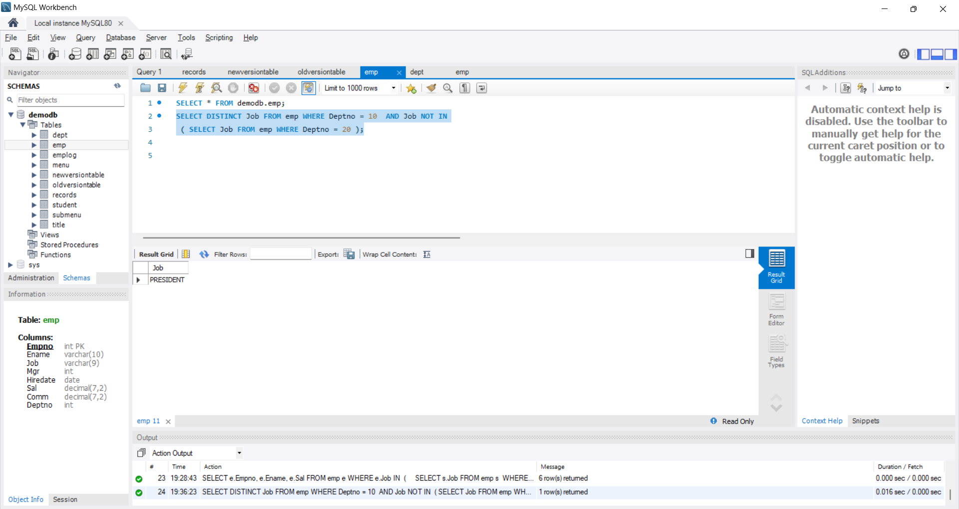

**Ans**(xviii) SELECT max(Sal) FROM emp;

**Ans**(xix) SELECT * FROM emp WHERE Sal = (SELECT MAX(Sal) FROM emp);

**Ans**(xx)

SELECT SUM(Sal) AS TotalSalForMgr FROM emp

WHERE Empno IN (SELECT DISTINCT Mgr FROM emp WHERE Mgr IS NOT NULL);

**Ans**(xxi)

SELECT * FROM emp WHERE Ename LIKE '%A%';

**Ans**(xxii)

SELECT *FROM emp e WHERE Sal =

( SELECT MIN(Sal) FROM emp WHERE Job = e.Job )

ORDER BY Job, Sal ASC;

**Ans**(xxiii)

SELECT * FROM emp WHERE Sal > (SELECT Sal FROM emp WHERE Ename = 'BLAKE');

**Ans**(xxiv) CREATE VIEW v1 AS SELECT e.Ename, e.Job, d.Dname, d.Loc

FROM emp e JOIN dept d ON e.Deptno = d.Deptno;

**Ans**(xxv) DELIMITER //

CREATE PROCEDURE GetEmployeesByDeptNo(IN dno INT)

BEGIN

SELECT e.Ename, d.Dname

FROM emp e

JOIN dept d ON e.Deptno = d.Deptno

WHERE e.Deptno = dno;

END //

DELIMITER ;

CALL GetEmployeesByDeptNo(10);

**Ans**(xxvi) Add column Pin with bigint data type in table student.

**Ans**(xxvi) ALTER TABLE student ADD COLUMN Pin BIGINT;

**Ans**(xxvii) ALTER TABLE student MODIFY COLUMN Sname VARCHAR(40);

**Ans** (xxviii) CREATE TRIGGER AfterSalaryUpdate

AFTER UPDATE ON emp

FOR EACH ROW

BEGIN

IF OLD.Sal <> NEW.Sal THEN

INSERT INTO emp_log (Empno, OldSal, NewSal, Action)

VALUES (NEW.Empno, OLD.Sal, NEW.Sal, 'New Salary');

END IF;

END;

**Ans**(xxix)

CREATE TRIGGER AfterSalaryUpdate

AFTER UPDATE ON emp

FOR EACH ROW

BEGIN

IF OLD.Sal <> NEW.Sal THEN

INSERT INTO emp_log (Empno, OldSal, NewSal, Action)

VALUES (NEW.Empno, OLD.Sal, NEW.Sal, 'New Salary');

END IF;

END;